https://wiki.tcsbank.ru/pages/viewpage.action?pageId=42077981
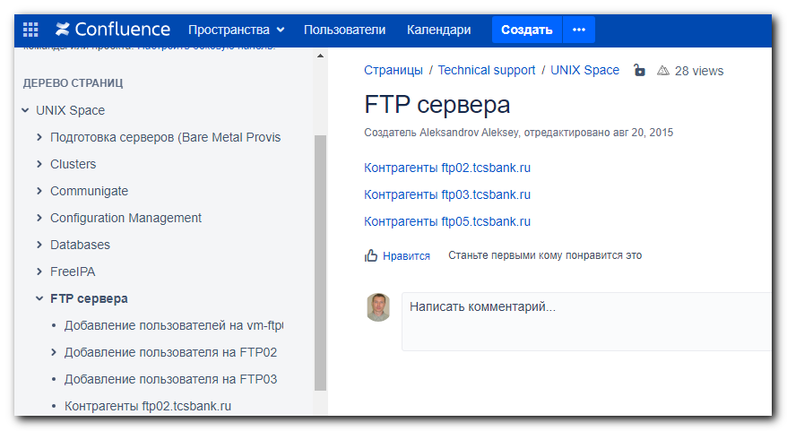

https://wiki.tcsbank.ru/pages/viewpage.action?pageId=42078281
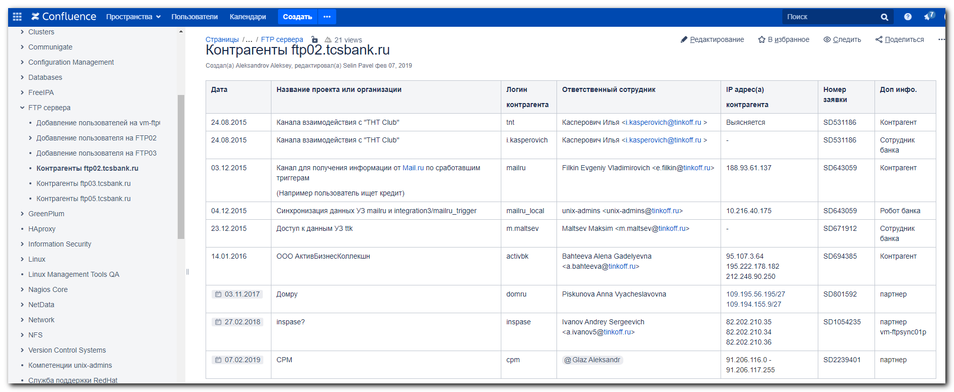

#
# Устаревшее, но всё же.
#
https://wiki.tcsbank.ru/display/NT/FTP02+clients+list
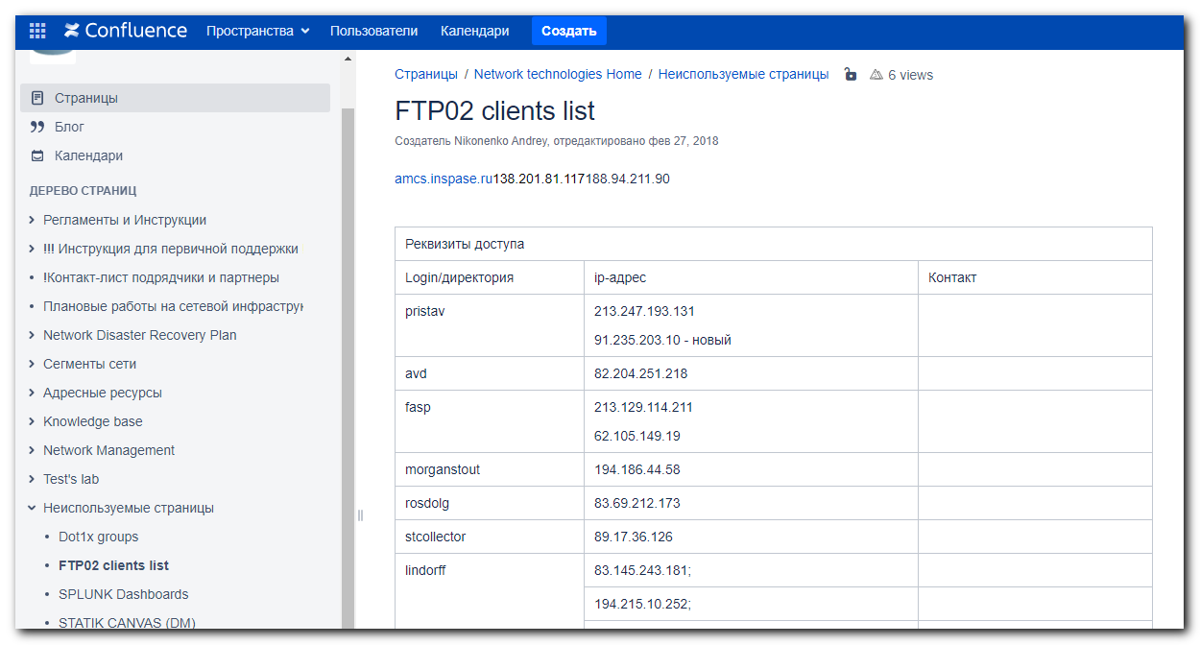

https://wiki.tcsbank.ru/pages/viewpage.action?pageId=4278610
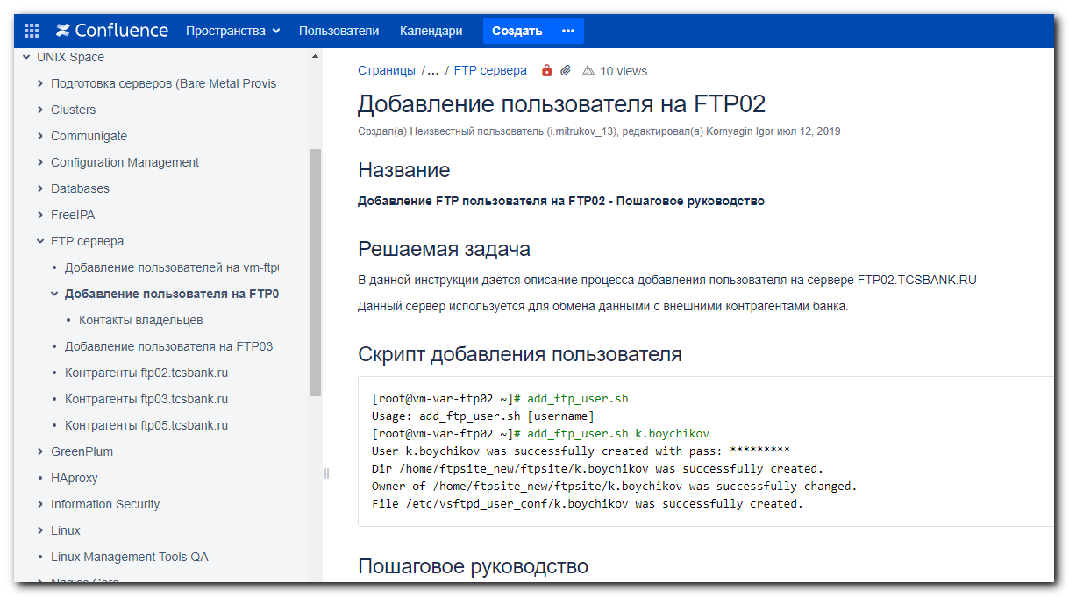

#
# Тоже устаревшее.
#
https://wiki.tcsbank.ru/pages/viewpage.action?pageId=287472931
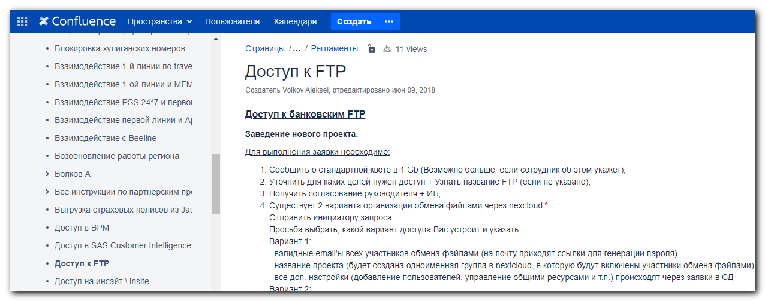

#
# 20210412
#
https://forge.tcsbank.ru/case/5254891/info
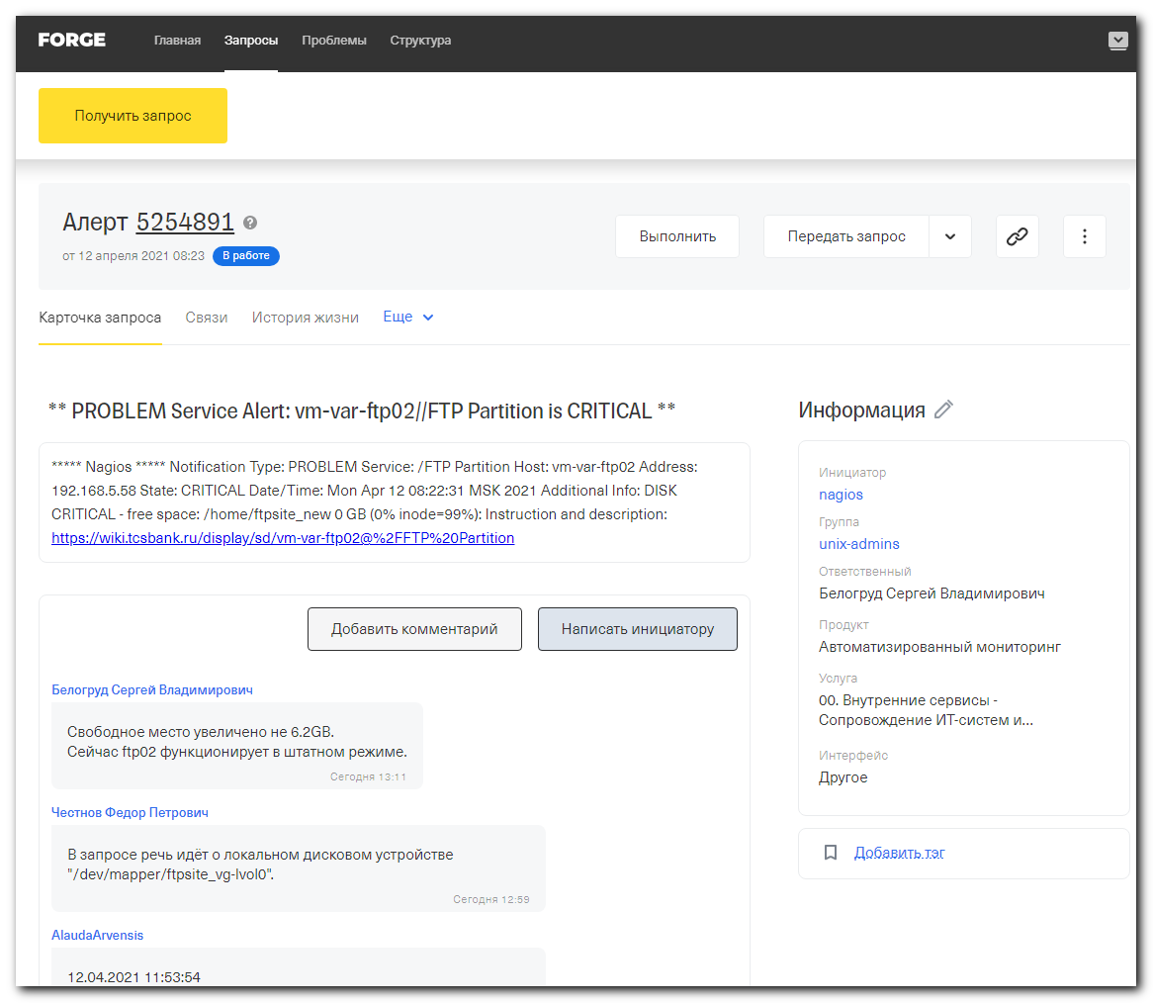

[root@vm-var-ftp02 ftpsite3]# du -sh /home/ftpsite_new/*
975M /home/ftpsite_new/ftpsite
222G /home/ftpsite_new/ftpsite2
354G /home/ftpsite_new/ftpsite3
16K /home/ftpsite_new/ftpsite4
1.8G /home/ftpsite_new/ftpsite5
20K /home/ftpsite_new/lost+found
783M /home/ftpsite_new/netdata
2.9G /home/ftpsite_new/sshsite
32K /home/ftpsite_new/tmp
[root@vm-var-ftp02 ftpsite3]#

atm
wincor

Поставлен acknowledge на nagios-проверку места на ftp02.
Отправлено письмо storage-admins.
Написано сообщение в Слак-канал help-storage.
Отправлено письмо известным владельцам ресурсов на ftp02 с просьбой удалить старое и не нужное.

[root@vm-var-ftp02 ftpsite3]# cd /home/ftpsite_new/ftpsite2
[root@vm-var-ftp02 ftpsite2]# echo "$(find . -size +100M -exec du -sh {} \;)"
242M ./virtual2/nprogs.sserov/Update/UFT_00022.msp
104M ./primcollect/ 02032021.7z
179M ./sns/SnSDumpTool_1052.7z
177M ./sns/SnsDump 2022.zip
214M ./sns/1301_SnSDumpTool.7z
...

[root@vm-var-ftp02 ftpsite2]# df -hT
Filesystem Type Size Used Avail Use% Mounted on
/dev/mapper/VolGroup00-LogVol00
ext3 18G 7.2G 9.3G 44% /
/dev/sda1 ext3 99M 13M 82M 14% /boot
tmpfs tmpfs 502M 0 502M 0% /dev/shm
/dev/mapper/ftpsite_vg-lvol0
ext3 394G 392G 0 100% /home/ftpsite_new
v6250-m1-dmz.tcsbank.ru:/vol/vfiler_dmz_vol1/ftp_data
nfs 500G 51G 450G 11% /mnt/data
[root@vm-var-ftp02 ftpsite2]# ls -Alh ./sns/1040/MEMORY.DMP
-rw------- 1 virtual virtual 6.2G Dec 5 2017 ./sns/1040/MEMORY.DMP
[root@vm-var-ftp02 ftpsite2]# mv ./sns/1040/MEMORY.DMP /mnt/data/
[root@vm-var-ftp02 ftpsite2]#

[root@vm-var-ftp02 ftpsite2]# df -hT
Filesystem Type Size Used Avail Use% Mounted on
/dev/mapper/VolGroup00-LogVol00
ext3 18G 7.2G 9.3G 44% /
/dev/sda1 ext3 99M 13M 82M 14% /boot
tmpfs tmpfs 502M 0 502M 0% /dev/shm
/dev/mapper/ftpsite_vg-lvol0
ext3 394G 386G 6.2G 99% /home/ftpsite_new
v6250-m1-dmz.tcsbank.ru:/vol/vfiler_dmz_vol1/ftp_data
nfs 500G 57G 444G 12% /mnt/data
[root@vm-var-ftp02 ftpsite2]# ls -Alh /mnt/data/
total 6.2G
drwxr-xr-x 8 virtual virtual 4.0K Mar 29 08:43 ftpsite
-rw------- 1 virtual virtual 6.2G Dec 5 2017 MEMORY.DMP
drwxrwxr-x 2 nextcloud nextcloud 4.0K Mar 21 2018 nextcloud
drwxrwxrwx 16 root root 4.0K Apr 12 06:02 .snapshot
[root@vm-var-ftp02 ftpsite2]#

[root@vm-var-ftp02 ~]# ls -Alh /mnt/data/ftpsite/
total 28K
drwxr-xr-x 3 virtual virtual 4.0K Dec 19 2017 a.alter
drwxr-xr-x 3 virtual virtual 4.0K Sep 3 2020 cpm
drwxr-xr-x 11 virtual virtual 4.0K Mar 22 2019 regionconsalt
drwxr-xr-x 7 virtual virtual 8.0K Jan 29 2020 rencredit
drwxr-xr-x 3 virtual virtual 4.0K Dec 19 2017 tm_tele2
drwxr-xr-x 3 virtual virtual 4.0K Dec 21 2017 zeppelin
[root@vm-var-ftp02 ~]#

[root@vm-var-ftp02 ~]# grep -irle "cpm" /etc/vsftpd*
/etc/vsftpd_user_conf/cpm
[root@vm-var-ftp02 ~]# cat /etc/vsftpd_user_conf/cpm
local_root=/mnt/data/ftpsite/cpm
write_enable=YES
guest_enable=YES
guest_username=virtual
[root@vm-var-ftp02 ~]#

[root@vm-var-ftp02 ~]# cat /etc/vsftpd_user_conf/sns
local_root=/home/ftpsite_new/ftpsite2/sns
write_enable=YES
guest_enable=YES
guest_username=virtual
[root@vm-var-ftp02 ~]#

[root@vm-var-ftp02 ~]# grep -ie "sns" /etc/fstab
[root@vm-var-ftp02 ~]#

[root@vm-var-ftp02 ~]# vim -R /etc/fstab
[root@vm-var-ftp02 ~]# vim -R /etc/vsftpd/user_list

[root@vm-var-ftp02 ~]# du -sh /home/ftpsite_new/ftpsite2/sns
101G /home/ftpsite_new/ftpsite2/sns
[root@vm-var-ftp02 ~]#

[root@vm-var-ftp02 ~]# mysql vsftpd
Reading table information for completion of table and column names
You can turn off this feature to get a quicker startup with -A

Welcome to the MySQL monitor. Commands end with ; or \g.
Your MySQL connection id is 6758152
Server version: 5.0.77-log Source distribution

Type 'help;' or '\h' for help. Type '\c' to clear the buffer.

mysql> select * from accounts where username="sns" ;
+-----+----------+------------------+
| id | username | password |
+-----+----------+------------------+
| 183 | sns | **** |
+-----+----------+------------------+
1 row in set (0.00 sec)

mysql> quit
Bye
[root@vm-var-ftp02 ~]#

[s.belogrud@nb2339]# lftp -e "set ftp:ssl-allow true; set ftp:ssl-protect-data true ; set passive-mode yes ; set ssl:verify-certificate no ; ls ; bye" -u
'sns','***' ftp02.tcsbank.ru -p 2121
drwx------ 2 503 503 4096 Jan 17 2018 1001
-rw-r----- 1 503 503 27737154 Mar 14 2019 10013_6010.zip
drwx------ 2 503 503 4096 Jan 31 2018 1003
drwx------ 2 503 503 4096 Feb 01 2018 1009
drwx------ 2 503 503 4096 Feb 08 2018 1038
...

[root@vm-var-ftp02 ~]# mkdir /mnt/data/ftpsite/sns
[root@vm-var-ftp02 ~]# ls -Alh /mnt/data/ftpsite/
total 32K
drwxr-xr-x 3 virtual virtual 4.0K Dec 19 2017 a.alter
drwxr-xr-x 3 virtual virtual 4.0K Sep 3 2020 cpm
drwxr-xr-x 11 virtual virtual 4.0K Mar 22 2019 regionconsalt
drwxr-xr-x 7 virtual virtual 8.0K Jan 29 2020 rencredit
drwxr-xr-x 2 root root 4.0K Apr 12 14:45 sns
drwxr-xr-x 3 virtual virtual 4.0K Dec 19 2017 tm_tele2
drwxr-xr-x 3 virtual virtual 4.0K Dec 21 2017 zeppelin
[root@vm-var-ftp02 ~]# chown virtual:virtual /mnt/data/ftpsite/sns
[root@vm-var-ftp02 ~]# ls -Alh /mnt/data/ftpsite/
total 32K
drwxr-xr-x 3 virtual virtual 4.0K Dec 19 2017 a.alter
drwxr-xr-x 3 virtual virtual 4.0K Sep 3 2020 cpm
drwxr-xr-x 11 virtual virtual 4.0K Mar 22 2019 regionconsalt
drwxr-xr-x 7 virtual virtual 8.0K Jan 29 2020 rencredit
drwxr-xr-x 2 virtual virtual 4.0K Apr 12 14:45 sns
drwxr-xr-x 3 virtual virtual 4.0K Dec 19 2017 tm_tele2
drwxr-xr-x 3 virtual virtual 4.0K Dec 21 2017 zeppelin
[root@vm-var-ftp02 ~]#

[s.belogrud@nb2339]# lftp -e "set ftp:ssl-allow true; set ftp:ssl-protect-data true ; set passive-mode yes ; set ssl:verify-certificate no ; cd 1040 ; ls
; bye" -u 'sns','***' ftp02.tcsbank.ru -p 2121
cd ok, каталог=/1040
drwx------ 2 503 503 4096 Feb 08 2018 080218
-rw------- 1 503 503 11214179 Nov 22 2017 2017.11.21.log
-rw------- 1 503 503 0 Dec 05 2017 WNREPORT 1040.ZIP
-rw------- 1 503 503 5696 Nov 21 2017 listProcess.txt
-rw------- 1 503 503 75553 Nov 21 2017 listServices.txt
drwx------ 2 503 503 4096 Dec 05 2017 winevt
[s.belogrud@nb2339]#

[root@vm-var-ftp02 ~]# rsync -a /home/ftpsite_new/ftpsite2/sns/ /mnt/data/ftpsite/sns/
Connection reset by 192.168.5.58 port 22
[s.belogrud@nb2339]#
[s.belogrud@nb2339]# ssh bsv@vm-var-ftp02
Last login: Mon Apr 12 15:14:20 2021 from 172.30.65.136
[bsv@vm-var-ftp02 ~]$ sudo -i
[sudo] password for bsv:
[root@vm-var-ftp02 ~]#
[root@vm-var-ftp02 ~]# rsync -a /home/ftpsite_new/ftpsite2/sns/ /mnt/data/ftpsite/sns/
[root@vm-var-ftp02 ~]# mv /mnt/data/MEMORY.DMP /mnt/data/ftpsite/sns/1040/
[root@vm-var-ftp02 ~]# ls /mnt/data/
ftpsite nextcloud
[root@vm-var-ftp02 ~]# ll /mnt/data/ftpsite/sns/1040/
total 6458940
drwx------ 2 virtual virtual 4096 Feb 8 2018 080218
-rw------- 1 virtual virtual 11214179 Nov 22 2017 2017.11.21.log
-rw------- 1 virtual virtual 5696 Nov 21 2017 listProcess.txt
-rw------- 1 virtual virtual 75553 Nov 21 2017 listServices.txt
-rw------- 1 virtual virtual 6576693248 Dec 5 2017 MEMORY.DMP
drwx------ 2 virtual virtual 4096 Dec 5 2017 winevt
-rw------- 1 virtual virtual 0 Dec 5 2017 WNREPORT 1040.ZIP
[root@vm-var-ftp02 ~]#
[root@vm-var-ftp02 ~]# vim /etc/vsftpd_user_conf/sns

[root@vm-var-ftp02 ~]# cat /etc/vsftpd_user_conf/sns
local_root=/mnt/data/ftpsite/sns
write_enable=YES
guest_enable=YES
guest_username=virtual
[root@vm-var-ftp02 ~]#

[root@vm-var-ftp02 ~]# service vsftpd restart
Shutting down vsftpd: [ OK ]
Starting vsftpd for vsftpd: [ OK ]
Starting vsftpd for vsftpd-secure: [ OK ]
[root@vm-var-ftp02 ~]#

[s.belogrud@nb2339]# lftp -e "set ftp:ssl-allow true; set ftp:ssl-protect-data true ; set passive-mode yes ; set ssl:verify-certificate no ; cd 1040 ; ls ; bye" -u 'sns','***' ftp02.tcsbank.ru -p 2121
cd ok, каталог=/1040
drwx------ 2 503 503 4096 Feb 08 2018 080218
-rw------- 1 503 503 11214179 Nov 22 2017 2017.11.21.log
-rw------- 1 503 503 6576693248 Dec 05 2017 MEMORY.DMP
-rw------- 1 503 503 0 Dec 05 2017 WNREPORT 1040.ZIP
-rw------- 1 503 503 5696 Nov 21 2017 listProcess.txt
-rw------- 1 503 503 75553 Nov 21 2017 listServices.txt
drwx------ 2 503 503 4096 Dec 05 2017 winevt
[s.belogrud@nb2339]#

# I ran this command during files transfer.
[root@vm-var-ftp02 ~]# du -sh /mnt/data/ftpsite/sns
91G /mnt/data/ftpsite/sns
[root@vm-var-ftp02 ~]# du -sh /mnt/data/ftpsite/sns
102G /mnt/data/ftpsite/sns
[root@vm-var-ftp02 ~]#
[root@vm-var-ftp02 ~]# du -sh /mnt/data/ftpsite/sns
108G /mnt/data/ftpsite/sns
[root@vm-var-ftp02 ~]#

#
# Here are candidats to move to nfs-resource.
#
[root@vm-var-ftp02 ~]# du -sh /home/ftpsite_new/ftpsite2/*
2.7M /home/ftpsite_new/ftpsite2/455d5e4d-a795-4f22-8d74-6ab124a50d3b (2).xlsx
795M /home/ftpsite_new/ftpsite2/4s
26M /home/ftpsite_new/ftpsite2/activbk
16K /home/ftpsite_new/ftpsite2/afpb
9.7M /home/ftpsite_new/ftpsite2/asd
24K /home/ftpsite_new/ftpsite2/avd
8.0K /home/ftpsite_new/ftpsite2/carecord
39M /home/ftpsite_new/ftpsite2/casp
16K /home/ftpsite_new/ftpsite2/cda
8.0K /home/ftpsite_new/ftpsite2/contrust
50M /home/ftpsite_new/ftpsite2/creditexpress
40K /home/ftpsite_new/ftpsite2/czinvest
24K /home/ftpsite_new/ftpsite2/dchl_service
152K /home/ftpsite_new/ftpsite2/ddm
12K /home/ftpsite_new/ftpsite2/deltam
18M /home/ftpsite_new/ftpsite2/dolgoff
44M /home/ftpsite_new/ftpsite2/eos
8.0K /home/ftpsite_new/ftpsite2/fasp
169M /home/ftpsite_new/ftpsite2/filbert
180K /home/ftpsite_new/ftpsite2/gcg
8.0K /home/ftpsite_new/ftpsite2/inbg
16K /home/ftpsite_new/ftpsite2/klever
8.0K /home/ftpsite_new/ftpsite2/konkord
252K /home/ftpsite_new/ftpsite2/kredytinkaso
84M /home/ftpsite_new/ftpsite2/libertygrant
8.0K /home/ftpsite_new/ftpsite2/lindorff
528K /home/ftpsite_new/ftpsite2/mba
16K /home/ftpsite_new/ftpsite2/morganstout
16G /home/ftpsite_new/ftpsite2/nicefraud
75G /home/ftpsite_new/ftpsite2/osgrm
4.0K /home/ftpsite_new/ftpsite2/pfb
4.0K /home/ftpsite_new/ftpsite2/phoenix
91M /home/ftpsite_new/ftpsite2/pkb
52K /home/ftpsite_new/ftpsite2/presco
118M /home/ftpsite_new/ftpsite2/primcollect
1.2M /home/ftpsite_new/ftpsite2/pristav
20G /home/ftpsite_new/ftpsite2/regionconsalt
4.0G /home/ftpsite_new/ftpsite2/rencredit
8.0K /home/ftpsite_new/ftpsite2/rosdolg
4.0K /home/ftpsite_new/ftpsite2/rssv
8.0K /home/ftpsite_new/ftpsite2/rusdebt
8.0K /home/ftpsite_new/ftpsite2/rusdolgnadzor
28K /home/ftpsite_new/ftpsite2/russcollector
88K /home/ftpsite_new/ftpsite2/sentinel
4.0K /home/ftpsite_new/ftpsite2/sns
760K /home/ftpsite_new/ftpsite2/sravni_ru
8.0K /home/ftpsite_new/ftpsite2/stcollector
8.0K /home/ftpsite_new/ftpsite2/U:\
8.0K /home/ftpsite_new/ftpsite2/usbcollector
27M /home/ftpsite_new/ftpsite2/vf
324K /home/ftpsite_new/ftpsite2/vildon
281M /home/ftpsite_new/ftpsite2/virtual2
12K /home/ftpsite_new/ftpsite2/ .xlsx
3.7M /home/ftpsite_new/ftpsite2/Y001560435.pdf
[root@vm-var-ftp02 ~]#

[root@vm-var-ftp02 ~]# du -sh /home/ftpsite_new/ftpsite3/*
8.0K /home/ftpsite_new/ftpsite3/a.a.melnikov
12K /home/ftpsite_new/ftpsite3/a.ayana
26M /home/ftpsite_new/ftpsite3/activbk
4.0G /home/ftpsite_new/ftpsite3/a.g.kozhevnikov
13M /home/ftpsite_new/ftpsite3/a.kimeev
2.5G /home/ftpsite_new/ftpsite3/a.labutin
196K /home/ftpsite_new/ftpsite3/a.pavkin
8.0K /home/ftpsite_new/ftpsite3/a.pinyagin
141G /home/ftpsite_new/ftpsite3/atm
192K /home/ftpsite_new/ftpsite3/atol
8.0K /home/ftpsite_new/ftpsite3/attu_support
553M /home/ftpsite_new/ftpsite3/a.v.kirillov
1.7M /home/ftpsite_new/ftpsite3/a.v.rudenko
8.0K /home/ftpsite_new/ftpsite3/a.zhabykeev
16K /home/ftpsite_new/ftpsite3/cda
30G /home/ftpsite_new/ftpsite3/crt2
8.0K /home/ftpsite_new/ftpsite3/crt3
40K /home/ftpsite_new/ftpsite3/czinvest
8.0K /home/ftpsite_new/ftpsite3/dataswapper
12K /home/ftpsite_new/ftpsite3/deltam
1.8G /home/ftpsite_new/ftpsite3/d.galiullin
8.0K /home/ftpsite_new/ftpsite3/d.korotov
8.0K /home/ftpsite_new/ftpsite3/d.m.korzhenkov
18M /home/ftpsite_new/ftpsite3/dolgoff
448K /home/ftpsite_new/ftpsite3/domru
8.0K /home/ftpsite_new/ftpsite3/dwh_skyeng
1.7M /home/ftpsite_new/ftpsite3/dwhsys
2.6G /home/ftpsite_new/ftpsite3/e.filkin
4.0K /home/ftpsite_new/ftpsite3/eldorado
553M /home/ftpsite_new/ftpsite3/e.verbitskiy
421M /home/ftpsite_new/ftpsite3/ibm-support
4.0G /home/ftpsite_new/ftpsite3/i.feklisov
68M /home/ftpsite_new/ftpsite3/inspase
68M /home/ftpsite_new/ftpsite3/inspase_read
1.8G /home/ftpsite_new/ftpsite3/k.bakulin
76M /home/ftpsite_new/ftpsite3/k.boychikov
16K /home/ftpsite_new/ftpsite3/klever
553M /home/ftpsite_new/ftpsite3/k.ogibalova
1.7M /home/ftpsite_new/ftpsite3/k.s.dereshev
1.9G /home/ftpsite_new/ftpsite3/logica
2.5G /home/ftpsite_new/ftpsite3/mailru
468K /home/ftpsite_new/ftpsite3/m.b.kuznetsov
1019M /home/ftpsite_new/ftpsite3/m.maltsev
4.0K /home/ftpsite_new/ftpsite3/nbki
12K /home/ftpsite_new/ftpsite3/netadmins
12K /home/ftpsite_new/ftpsite3/newnpr_bpm_dev
76M /home/ftpsite_new/ftpsite3/n.kruzhilov
1.7M /home/ftpsite_new/ftpsite3/nspk
8.0K /home/ftpsite_new/ftpsite3/n.zavorina
5.4M /home/ftpsite_new/ftpsite3/ottreg
4.0G /home/ftpsite_new/ftpsite3/p.kuptsov
1.3G /home/ftpsite_new/ftpsite3/qiwi
65M /home/ftpsite_new/ftpsite3/qiwiscor
3.5G /home/ftpsite_new/ftpsite3/recognition
4.0K /home/ftpsite_new/ftpsite3/r.gentyllo
1.7M /home/ftpsite_new/ftpsite3/r.giniyatov_int
4.0K /home/ftpsite_new/ftpsite3/rssv
349M /home/ftpsite_new/ftpsite3/sap_support
8.0K /home/ftpsite_new/ftpsite3/sitecatalist
4.0K /home/ftpsite_new/ftpsite3/skyeng
163M /home/ftpsite_new/ftpsite3/svyaznoy
8.0K /home/ftpsite_new/ftpsite3/tcs5322
4.0K /home/ftpsite_new/ftpsite3/tcs_monitor
1.1G /home/ftpsite_new/ftpsite3/terrasoft
4.0K /home/ftpsite_new/ftpsite3/tnt
1.9M /home/ftpsite_new/ftpsite3/t.shalimov
1019M /home/ftpsite_new/ftpsite3/ttk
76M /home/ftpsite_new/ftpsite3/t.vinogradova
13M /home/ftpsite_new/ftpsite3/u.khusainov
9.4M /home/ftpsite_new/ftpsite3/ulmart
9.4M /home/ftpsite_new/ftpsite3/ulmart_sas
1.1G /home/ftpsite_new/ftpsite3/v.adamenko
553M /home/ftpsite_new/ftpsite3/v.efremov
324K /home/ftpsite_new/ftpsite3/vildon
1.9M /home/ftpsite_new/ftpsite3/v.malygin
4.0K /home/ftpsite_new/ftpsite3/v.sakalkin
141G /home/ftpsite_new/ftpsite3/wincor
3.5M /home/ftpsite_new/ftpsite3/wwf
3.5M /home/ftpsite_new/ftpsite3/wwf_sas
1.9M /home/ftpsite_new/ftpsite3/y.tikhomirova
5.1G /home/ftpsite_new/ftpsite3/zingaya
[root@vm-var-ftp02 ~]#

[root@vm-var-ftp02 ~]# ls -Alh /home/ftpsite_new/ftpsite3/atm/
total 8.0K
drwxr-x--- 2 virtual virtual 4.0K Nov 7 2019 .snapshot
drwxrwxrwx 11 virtual virtual 4.0K Nov 7 2019 wincor
[root@vm-var-ftp02 ~]#

#
# Here I tried to move /home/ftpsite_new/ftpsite2/regionconsalt to nfs-resource. But, it was moved there already before.
# So I only umount old unnecessary mounted point and comment it in /etc/fstab.
#
[root@vm-var-ftp02 ~]# grep -irle "regionconsalt" /etc/vsftpd*
/etc/vsftpd_user_conf/regionconsalt
[root@vm-var-ftp02 ~]# cat /etc/vsftpd_user_conf/regionconsalt
local_root=/mnt/data/ftpsite/regionconsalt
write_enable=YES
guest_enable=YES
guest_username=virtual
[root@vm-var-ftp02 ~]# grep -ie "regionconsalt" /etc/fstab
/mnt/data/ftpsite/regionconsalt /home/ftpsite_new/ftpsite2/regionconsalt none rw,bind 0 0
[root@vm-var-ftp02 ~]#

[root@vm-var-ftp02 ~]# find /home/ftpsite_new/ -maxdepth 2 -iname regionconsalt
/home/ftpsite_new/ftpsite2/regionconsalt
[root@vm-var-ftp02 ~]#

[root@vm-var-ftp02 ~]# grep -ie "regionconsalt" /etc/vsftpd/user_list
[root@vm-var-ftp02 ~]#

[root@vm-var-ftp02 ~]# id regionconsalt
id: regionconsalt: No such user
[root@vm-var-ftp02 ~]#

[root@vm-var-ftp02 ~]# ls -Alh /mnt/data/ftpsite/regionconsalt/
total 83M
drwxr-x--- 27 virtual virtual 4.0K Oct 10 2018 ????????????? ????? ??????????? ??????????
drwxr-x--- 3 virtual virtual 4.0K Mar 15 2019 ?????????????? ??????? ??? ?? ? ???
drwxr-x--- 2 virtual virtual 4.0K Aug 27 2018 0046910311_???????
drwxr-x--- 2 virtual virtual 4.0K Sep 30 2018 0195017678_??????????? ???????
drwxr-x--- 2 virtual virtual 4.0K Dec 7 2018 ????????? 07.12.2018
drwxr-x--- 2 virtual virtual 4.0K Jul 31 2018 ??????? 2017
drwxr-x--- 2 virtual virtual 4.0K Sep 10 2018 ???? 2018
drwxr-x--- 2 virtual virtual 4.0K Mar 22 2019 ?? 7.41
-rw-r----- 1 virtual virtual 575K Jul 31 2018 !!!?????? ? ???????? ?????? ? 91 ??? ? ???????? ? 33 ?-? ?? 26.07.2018.xlsx
-rw-r----- 1 virtual virtual 11M Dec 24 2018 ?????????? ???????.tif
drwxr-x--- 193 virtual virtual 16K Mar 15 2019 Welcomepack ?? ????????????????
-rw-r----- 1 virtual virtual 71M Mar 15 2019 ?????????????? ??????? ??? ?? ? ???.zip
[root@vm-var-ftp02 ~]#

#
# I unmounted this directory from local filesystem.
# I didn't understand for what it could be used.
#
[root@vm-var-ftp02 ~]# umount /home/ftpsite_new/ftpsite2/regionconsalt
[root@vm-var-ftp02 ~]# vim /etc/fstab
[root@vm-var-ftp02 ~]# ls -Alh /home/ftpsite_new/ftpsite2/regionconsalt/
total 0
[root@vm-var-ftp02 ~]# grep -ie "regionconsalt" /etc/fstab
# /mnt/data/ftpsite/regionconsalt /home/ftpsite_new/ftpsite2/regionconsalt none rw,bind 0 0
[root@vm-var-ftp02 ~]#

[s.belogrud@nb2339]# lftp -e "set ftp:ssl-allow true; set ftp:ssl-protect-data true ; set passive-mode yes ; set ssl:verify-certificate no ; ls ; bye" -u 'regionconsalt','****' ftp02.tcsbank.ru -p 2121
-rw-r----- 1 503 503 587971 Jul 31 2018 !!! 91 33 26.07.2018.xlsx
drwxr-x--- 2 503 503 4096 Aug 27 2018 0046910311_
drwxr-x--- 2 503 503 4096 Sep 30 2018 0195017678_
drwxr-x--- 193 503 503 16384 Mar 15 2019 Welcomepack
drwxr-x--- 2 503 503 4096 Dec 07 2018 07.12.2018
drwxr-x--- 3 503 503 4096 Mar 15 2019
-rw-r----- 1 503 503 74381738 Mar 15 2019 zip
-rw-r----- 1 503 503 10809338 Dec 24 2018 tif
drwxr-x--- 27 503 503 4096 Oct 10 2018
drwxr-x--- 2 503 503 4096 Mar 22 2019 7.41
drwxr-x--- 2 503 503 4096 Jul 31 2018 2017
drwxr-x--- 2 503 503 4096 Sep 10 2018 2018
[s.belogrud@nb2339]#

#
# This directory /home/ftpsite_new/ftpsite2/osgrm belongs to no one.
# I think it is not used any more. But it takes 75GB local drive.
# But for any case, I backed up it to nfs-resource.
#
[root@vm-var-ftp02 ~]# grep -irle "osgrm" /etc/vsftpd*
[root@vm-var-ftp02 ~]# id osgrm
id: osgrm: No such user
[root@vm-var-ftp02 ~]# ls -Alkh /home/ftpsite_new/ftpsite2/osgrm
total 64K
drwxr-x--- 2 virtual virtual 4.0K Aug 12 2019 ?????? ???
drwx------ 3 virtual virtual 4.0K Mar 3 2017 ??????? ???????
drwx------ 4 virtual virtual 4.0K Mar 3 2017 ???????? -?? ???????
drwx------ 2 virtual virtual 4.0K Mar 3 2017 ??????????
drwx------ 3 virtual virtual 4.0K Dec 7 2016 ???????????? ?????
drwx------ 3 virtual virtual 4.0K Nov 23 2015 ??????_23.11.2015
drwx------ 12 virtual virtual 4.0K Mar 3 2017 28.08.2016
drwx------ 7 virtual virtual 4.0K Mar 3 2017 30.06.2016
drwx------ 4 virtual virtual 4.0K Jul 15 2016 COURT
drwx------ 4 virtual virtual 4.0K Jul 3 2017 ??????, COURT_4_21.06.2017
drwx------ 23 virtual virtual 4.0K Jul 2 2017 ?????? COURT_4_30.05.2017
drwx------ 2 virtual virtual 4.0K Mar 6 2017 OVD
drwx------ 8 virtual virtual 4.0K Mar 14 2017 ?????? OVD4_25.11.2016
drwx------ 19 virtual virtual 4.0K Mar 23 2017 ?????? OVD5_07.02.2017
drwx------ 2 virtual virtual 4.0K Jun 30 2016 Part 1
drwxr-x--- 4 virtual virtual 4.0K Sep 2 2019 RM60838_SVEA
[root@vm-var-ftp02 ~]# grep -ie "osgrm" /etc/fstab
[root@vm-var-ftp02 ~]#

[root@vm-var-ftp02 ~]# mysql vsftpd
Reading table information for completion of table and column names
You can turn off this feature to get a quicker startup with -A

Welcome to the MySQL monitor. Commands end with ; or \g.
Your MySQL connection id is 6758300
Server version: 5.0.77-log Source distribution

Type 'help;' or '\h' for help. Type '\c' to clear the buffer.

mysql> select * from accounts where username="osgrm" ;
Empty set (0.00 sec)

mysql> quit
Bye
[root@vm-var-ftp02 ~]#

[root@vm-var-ftp02 ~]# find /home/ftpsite_new/ -maxdepth 3 -iname osgrm*
/home/ftpsite_new/ftpsite2/osgrm
[root@vm-var-ftp02 ~]#

[root@vm-var-ftp02 ~]# mkdir /mnt/data/ftpsite/osgrm
[root@vm-var-ftp02 ~]# chown virtual:virtual /mnt/data/ftpsite/osgrm
[root@vm-var-ftp02 ~]# rsync -a /home/ftpsite_new/ftpsite2/osgrm/ /mnt/data/ftpsite/osgrm/
[root@vm-var-ftp02 ~]#

[root@vm-var-ftp02 ~]# rm -rf /home/ftpsite_new/ftpsite2/osgrm/*

[root@vm-var-ftp02 ~]# df -hT /home/ftpsite_new
Filesystem Type Size Used Avail Use% Mounted on
/dev/mapper/ftpsite_vg-lvol0
ext3 394G 210G 182G 54% /home/ftpsite_new
[root@vm-var-ftp02 ~]#

